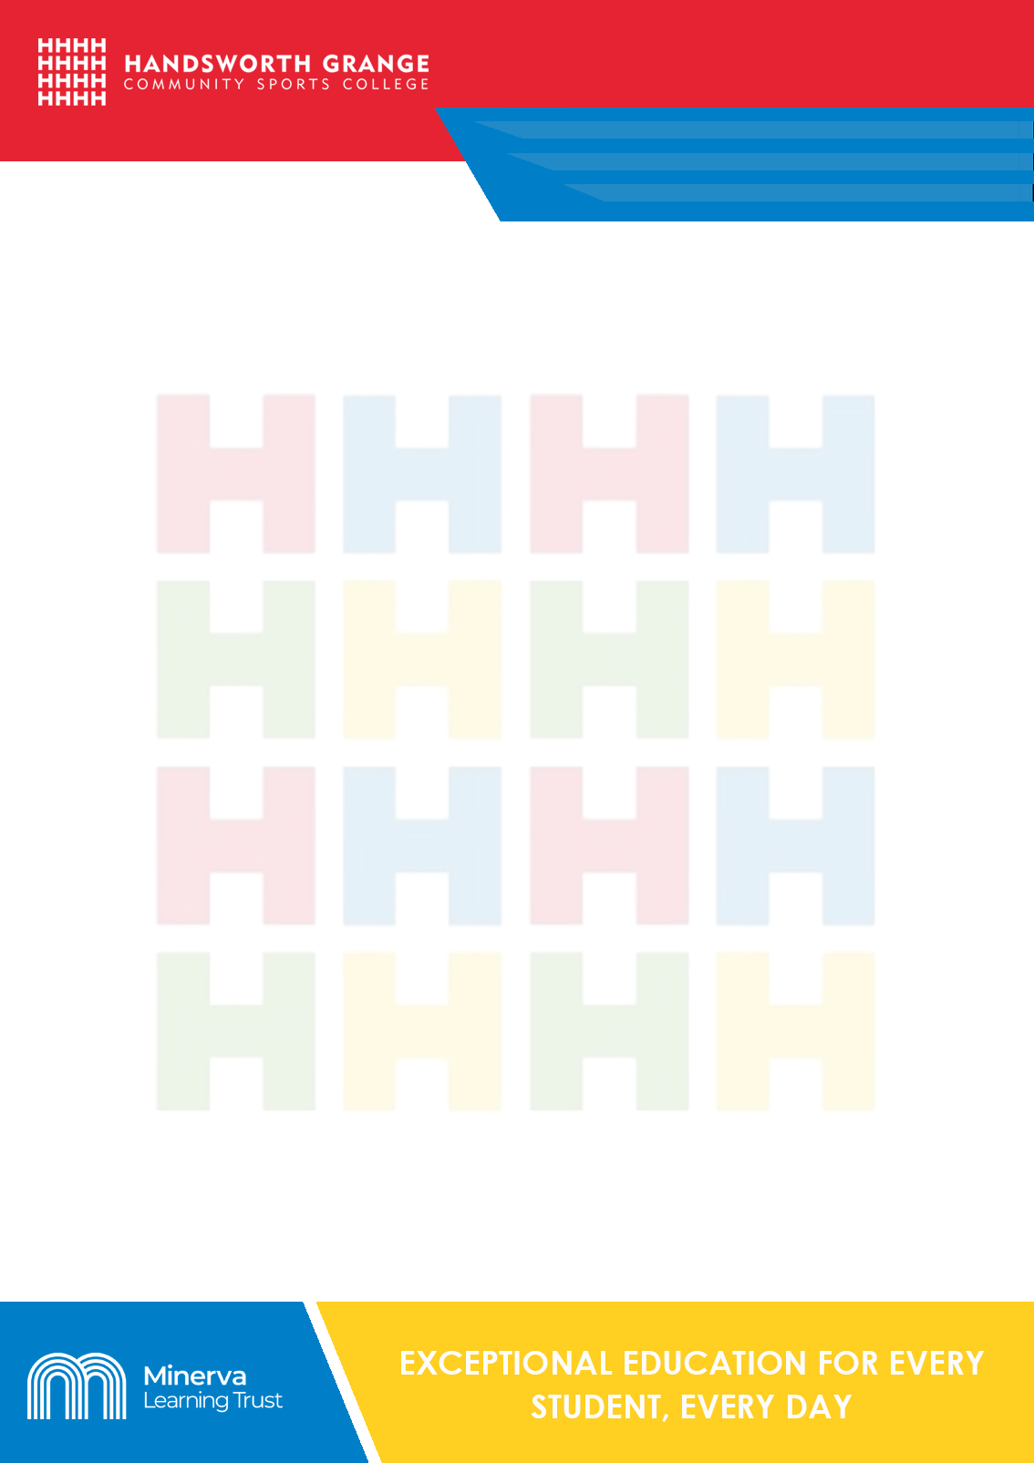
Culture Challenge
What is ‘culture’?

Art, music, literature, etc., thought of as a group.
The customs and beliefs, art, way of life and social organisation of a particular country or group.
Experiences outside of the classroom are extremely valuable. They can help you to develop knowledge, skills, confidence and vocabulary that help you to connect with the wider world. Employers feel that cultural experiences are important. They can be lots of fun too!

Challenge: Take part in as many cultural experiences as possible. You should aim for 7 in year 7, 8 in year 8, 9 in year 9 etc. You can choose which experiences to collect by going to our website. Ask a teacher or adult to verify your experiences by signing each box once you have described your experiences.

Please remember to take care when doing any of these tasks, not to film anyone without their permission and most importantly of all: Make sure that a responsible adult knows what you are doing.

You will find below, 2 pages for activities to try and a sheet to record your activities!

The Challenges

Find |  | Make
A famous location from Sheffield history (make sure you are accompanied)  3 examples of art on buildings around Sheffield city centre (make sure you are accompanied)  Your local library, join, and take out a book that someone else has recommended to you  A piece of music from the 1950s, 1960s, 1970s, 1980s, and 1990s: listen to them all, rank them in order of which you like best and then discuss your choices with an older member of your family.  Your family tree and make a poster for everyone in the family  A Sheffield war memorial (make sure you are accompanied) |  | Kite and fly it  Film  Board game (for a young child)  Meal for someone special (get someone to supervise you)  New outfit by cutting up bits of old clothes you never wear anymore (ask for help with the cutting if you need it and get permission to cut the clothes up!)  Wildlife area in your yard or garden (get permission from an adult first)  Picture of a family member or friend in pencil, paint or digital software  A 3D model using a computer programme
Learn |  | Go
A circus skill  A magic trick  Sign Language  A new sport |  | On a picnic with family or friends after you’ve made the food for everyone  On a journey without your mobile (accompanied)  Inside a building you’ve never been in before (get permission if you need it)  To two shops to compare the prices of something, then buy it from the cheaper one
See
The stars at night
Birds looking after their young
A Sheffield sports team (that isn’t Sheffield United or Sheffield Wednesday)

The Challenges
Try |  | Help
Rapping to an audience  Reading poetry to an audience  Making your own art exhibition  Climbing a tree (be careful and have a friend or family member there to help you!)  Eating a kind of food you’ve never tried before  Opening a bank account  Growing your own plant or vegetable  Supporting an English or British athlete on TV – shouting and yelling them on as though you are in the stadium with them!  Getting up before dawn to watch the dawn chorus (make sure your family know!) |  | An old person in your neighbourhood with their garden or their washing up (Ask your family to help you find the right old person)  A charity by volunteering  Fund-raise for a good cause  Go shopping for a family member, take cash and work out the change you’re due before the cashier tells you  Assemble a piece of flat pack furniture  A family member fix something in the house or garden  Read to a younger brother or sister for 15 minutes one night every week  A friend who is sad by making them a card
Write to |  | Play
A famous person, telling them why you like their work  A local politician, asking them about a decision that affects your life  A family member telling them why they’re so special to you |  | Catch and throw to 100 (or 1000 or 1000000) with a friend  An endurance running race against a friend: you have to run for at least 30 minutes non-stop  At being mum or dad – cook, clean and care for everyone in the family for the weekend

 | Year 7 | Year 8 | Year 9 | Year 10 | Year 11 | Signature
1st
2nd
3rd
4th
5th
6th
7th | PASS
8th | MERIT | PASS
9th |  | MERIT | PASS
10th |  |  | MERIT | PASS
11th |  |  |  | MERIT | PASS
12th |  |  |  |  | MERIT
Describe the challenge completed in the boxes. Then ask your form teacher to sign!
The Worksheet

