RE: Ofsted Report November 2022

Dear Parent/Carer,

I am writing to inform you that the Ofsted report from our inspection in November 2022 is now available to view on the school’s website.

As you will see, the overall judgement is that the school Requires Improvement. This means the school will be inspected again within the next 30 months.

The report highlights a number of strengths such as:

- the overall Quality of Education which was graded as Good
- the curriculum plans and teaching of English, Mathematics, Science and Technology which was identified as a strength of the school
- the behaviour and engagement of students in lessons
- the high expectations of staff
- the good relationships between staff and students
- that pupils feel safe at school
- the support and adaptations to teaching for students with Special Educational Needs
- the personalised support students receive to help prepare them for their next steps in education or employment
- the effective teaching for those students who are not yet fluent readers
- a broad and well-designed enrichment programme
- the effective arrangements for safeguarding

The report also highlights some areas for development such as:

- improving the behaviour of a minority of students at social times
- improving the Personal Development curriculum and how it is structured, designed and implemented to ensure that all students knowledge of different cultures, religions and beliefs is strong
- ensuring that the implementation of new policies are communicated more clearly and are consistent with the School and Trust’s aims and vision
We accept the findings of the inspectors and the subsequent report and have taken swift and appropriate action to develop a Rapid Action Plan to address these issues. A few examples of the immediate actions we have taken are given below:

- we have increased the number of staff available to support at lunchtimes and have implemented a split lunch to reduce the number of students out on lunch together
- we have invested in additional pastoral staff to provide increased support to our students and have provided access to a School Counsellor, Educational Psychologist and a Speech and Language specialist to improve emotional regulation of our students
- we are redesigning our whole school curriculum model to allow for more discrete Citizenship and RE curriculum time to ensure our students are better prepared for life in Modern Britain
- we are further developing our Citizenship curriculum to ensure that we further improve our students’ knowledge and understanding of the wider world, the rule of law and of other cultures
- we are investigating different methods of improving communication and engagement with parents and carers and will be shortly setting up our Parent Forum
I appreciate the overall outcome judgement for the school is not what we were hoping for, however, there are numerous positives that were highlighted in the report that the school can build upon to ensure we deliver an exceptional education for our students and families.

Thank you for your continued support.

Yours sincerely
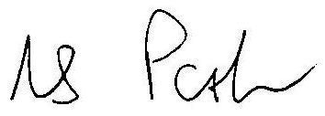

Mr N Parker Bev Matthews
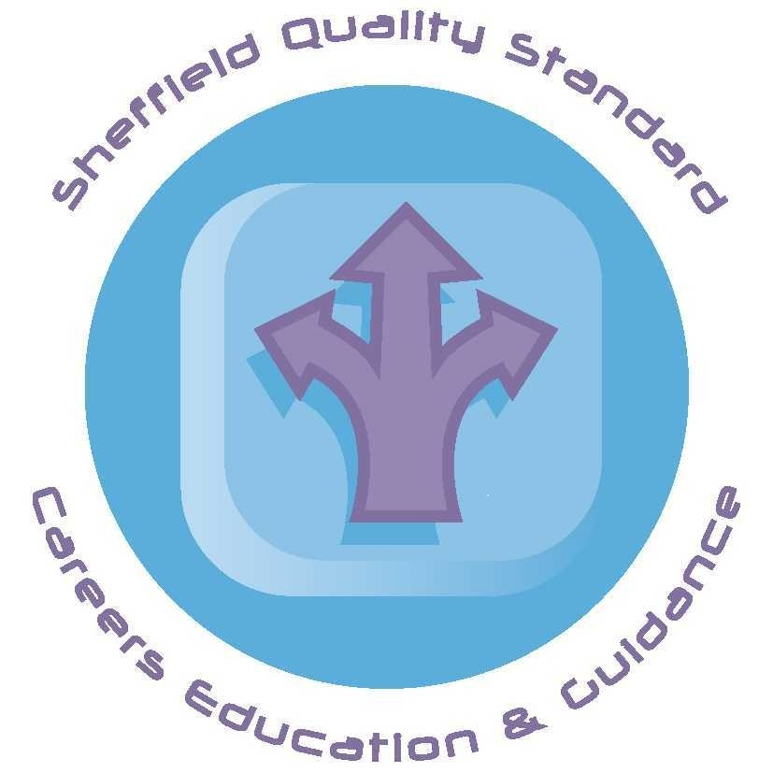
Headteacher CEO

